TASK-2

‘The frequency distribution of the word “Donald Trump” on the internet in different years is as follows:

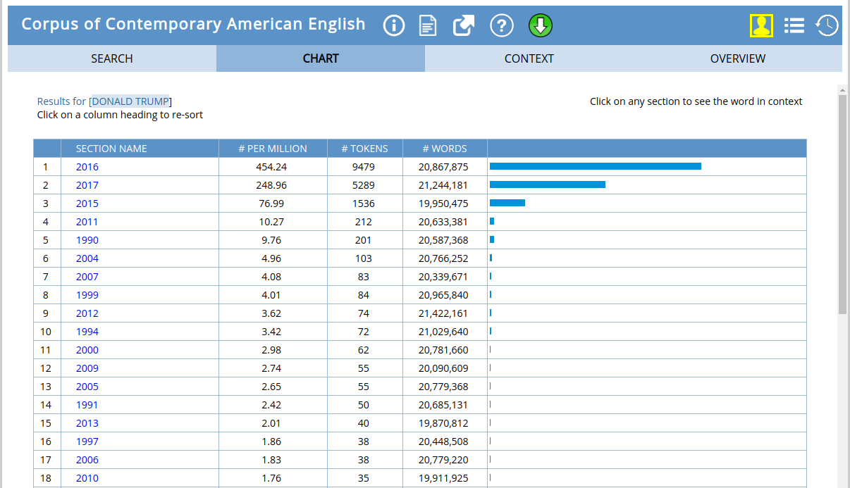

This word is mostly referred in the year 2016 because Donald Trump was a candidate for presidential elections of United State of America and there was a lot of hustle around the world.

In 2017, he was second mostly referred because he sworn in as the president of US on 20th Jan 2017 and there were a lot of important decisions taken by him in the first year.

